Stage 3 SPecial Interest Areas HALO Guide
Domains of Learning, Stage Learning Outcomes, and Key Capabilities

Contents
Introduction 3
Acute Inpatient Pain 5
Additional Intensive Care Medicine 7
Anaesthesia for Bariatric Surgery 10
Anaesthesia for Cardiac Surgery 12
Anaesthesia for Complex Orthopaedic Surgery 14
Anaesthesia for Hepato-Pancreato-Biliary Surgery 16
Anaesthesia for Major General Surgery 18
Anaesthesia for Neurosurgery 20
Anaesthesia for Ophthalmic Surgery 22
Anaesthesia for Patients with Complex Airway 24
Anaesthesia for Plastic Surgery and Burns Management 26
Anaesthesia for Thoracic Surgery 28
Anaesthesia for Vascular Surgery 30
Anaesthesia in Resource Poor Environments 32
Education and Training 34
Management and Professional and Regulatory Requirements 36
Military Anaesthesia 38
Obstetric Anaesthesia 40
Paediatric Anaesthesia 42
Pain Medicine 44
Perioperative Medicine 47
Regional Anaesthesia 49
Research and Managing Data 51
Safety and Quality Improvement 53
Transfer Medicine 55
Trauma and Stabilisation 57

Introduction
During stage 3 of the Anaesthetics Curriculum, 12 months (whole time equivalent) of training must be undertaken in one or more areas of special interest. This allows the anaesthetist in training to develop knowledge and skills to enable them to gain the capabilities required to be an independent practitioner. It also prepares them for specialised areas of anaesthetic practice that they may want to pursue as a consultant or in preparation for additional training opportunities that might be undertaken in a more specialised area of anaesthetics practice after gaining CCT.
Special Interest Area (SIA) training is not separate from that of stage 3. In fact the capabilities acquired during this training inform the capabilities of stage 3. This is particularly relevant for the non-clinical domains of learning. Stage 3 domains and the special interest areas together lead to achievement of independent practice.
The SIAs are undertaken over a period of one year during stage 3 of training. The time taken in each SIA depends on the type of SIA. The year may be a single SIA or combination of SIAs such as:
- 1 year of single SIA from group 1 or 2 x 6 month SIA from group 1
- 1 SIA from group 1 plus 1 or 2 from group 2
- up to 3 from group 2
- Additional Intensive Care plus 1 from group 1 or 1 or 2 from group 2.
Those in the Dual Anaesthetics and ICM programme will use the SIA year for completing stage 3 ICM training.
Anaesthetists in training who are looking to have paediatric lists as a significant part of their job plan as a consultant in a non-tertiary centre should consider doing the SIA in Paediatric Anaesthesia, gaining training and experience in the capabilities that relate to: For those intending to practice and potentially lead paediatric anaesthesia in a non-tertiary setting.
Anaesthetists in training undertaking Pre-Hospital Emergency Medicine (PHEM) training will do the Transfer Medicine and Trauma and Stabilisation SIAs plus the stage 3 Resuscitation and Transfer HALO in their PHEM year.

SIA Groups

Group 1: 6 months to 1 year
- Anaesthesia for Cardiac Surgery
- Anaesthesia for Neurosurgery
- Obstetric Anaesthesia
- Paediatric Anaesthesia
- Pain Medicine

Group 2: 3 to 6 months
- Acute Inpatient Pain
- Anaesthesia for Bariatric Surgery
- Anaesthesia for Complex Orthopaedic Surgery
- Anaesthesia for Hepato-Pancreato-Biliary Surgery
- Anaesthesia for Major General Surgery
- Anaesthesia for Ophthalmic Surgery
- Anaesthesia for Patients with Complex Airway
- Anaesthesia for Plastic Surgery and Burns Management
- Anaesthesia in Resource Poor Environments
- Anaesthesia for Thoracic Surgery
- Anaesthesia for Vascular Surgery
- Military Anaesthesia
- Perioperative Medicine
- Regional Anaesthesia
- Transfer Medicine
- Trauma and Stabilisation

Additional Intensive Care: 6 months
In this guidance for the SIAs examples are given of the experience and evidence suggested for the key capabilities. Schools of Anaesthesia may wish to adapt these examples to local requirements depending on the local provision of training in these areas.

Non clinical SIAs
Up to 6 months of SIA time can be used to complete SIAs that relate to non-clinical domains of learning in any one of the following:
- Management and Professional and Regulatory Requirements
- Safety and Quality Improvement
- Education and Training
- Research and Managing Data.

Acute Inpatient Pain

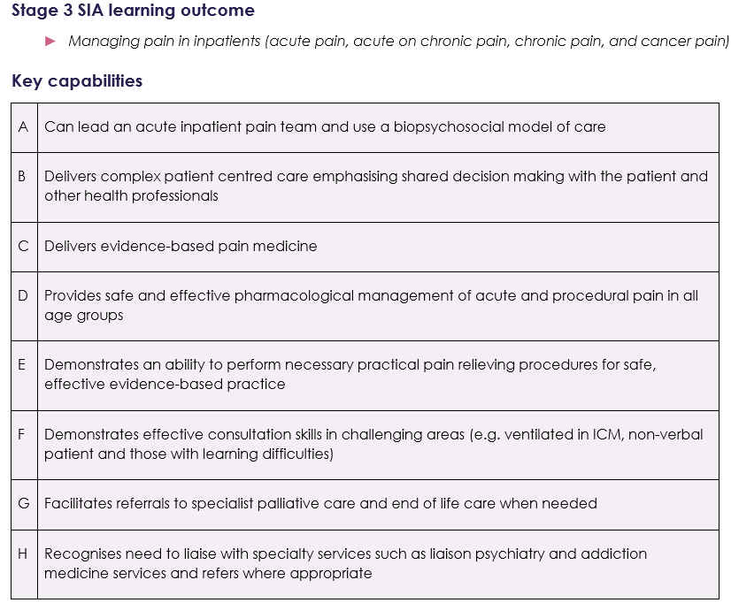

Examples of evidence

Experience and logbook:
- experience of managing acute and acute on chronic pain in the acute hospital setting and in pain management clinics, pain intervention lists, pain interventions as part of end of life care which may include terminal care setting.

Supervised Learning Events (SLEs) can be used to demonstrate:
- safe and effective pharmacological management of acute, acute on chronic and procedural pain in all groups
- explanation of clinical reasoning behind diagnostic and clinical management decisions to patients/carers/guardians and other colleagues
- appropriate pharmacological knowledge for safe short and long term prescribing of opioids
- ability to manage complications from interventional procedures and pharmacological management for pain
- appropriate clinical reasoning by analysing physical and psychological findings
- appropriate and timely liaison with other medical specialty services when required
- application of effective team working strategies to ensure that effective prioritisation, communication and shared decision making occurs
- development of an individualised care plan, including anticipatory prescribing at end of life
- appropriate application of evidence based treatments for pain management
- practical procedural skills for management of acute inpatient pain
- lead inpatient pain review round in collaboration with MDT.

Personal Activities and Personal Reflections may include:
- national and international courses or conferences related to Acute Inpatient Pain
- presentation at relevant meeting eg abstract or free paper
- development of guidelines and policies related to Acute Inpatient Pain
- leadership training and demonstration of ability to lead an inpatient acute pain service
- attendance at multi-disciplinary pain meetings.

Other evidence:
- satisfactory MSF.

Suggested supervision level
- 4 - should be able to manage independently with no supervisor involvement (although should inform consultant supervisor as appropriate to local protocols).

Cross links with other domains and capabilities
- all non-clinical domains of learning
- General Anaesthesia
- Pain

Additional Intensive Care Medicine
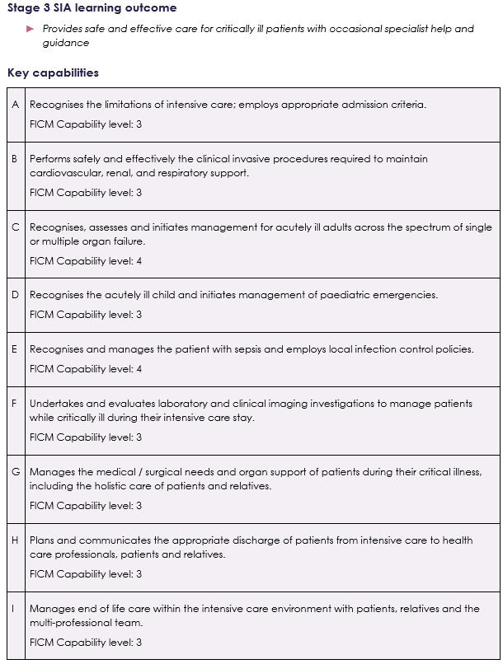
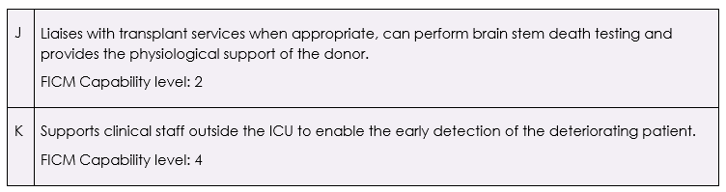

Examples of evidence

Experience and logbook:
- experience in an ICU recognised for stage 3 ICM training including on call commitments
- ICU follow up clinics.

Supervised Learning Events (SLEs) can be used to demonstrate:
- assessment and management of cases in accordance with capability levels set out above
- examples may include management of severe sepsis, multi-trauma, post-operative management following complex major surgery, severe burns, diagnosis of brain stem death and management of the potential organ donor
- assessment of acutely ill child including initial resuscitation of paediatric emergencies
- practical procedures as listed in key capability B
- other practical procedures may include percutaneous tracheostomy, bronchoscopy, use of ultrasound in intensive care including use of echocardiography
- ICU Ward round management and discharge planning
- Critical Care Outreach review
- Communication with relatives including discussion of withdrawal of support.

Personal Activities and Personal Reflections may include:
- national or international meetings related to Intensive Care Medicine
- presentation at relevant meeting eg abstract or free paper
- development of guidelines and policies related to Intensive Care Medicine
- leadership of QI projects related to ICM
- review of mortality
- teaching and training of other medical and nursing staff and allied health professionals
- simulation training related to management of critical care scenarios
- attendance at debriefing sessions following stressful episodes
- leadership training and demonstration of ability to lead ICU ward rounds
- attendance at ICU follow up clinics and appreciation of post intensive care syndrome
- attendance at ICU business or multidisciplinary meetings
- attendance at Trust or Health Board senior management meetings.

Other evidence:
- satisfactory MSF.

FICM capability levels
Level | Task orientated capability | Knowledge orientated capability | Patient management  capability
1 | Performs task under direct supervision. | Very limited knowledge; requires considerable guidance to solve a problem within the area. | Can take history, examine and arrange investigations for straight forward case (limited differential diagnosis). Can initiate emergency management and continue a management plan, recognising acute divergences from the plan. Will need help to deal with these.
2 | Performs task in straightforward circumstances, requires help for more difficult situations. Understands indications and complications of task. | Sound basic knowledge; requires some guidance to solve a problem within the area. Will have knowledge of appropriate guidelines and protocols. | Can take history, examine and arrange investigations in a more complicated case. Can initiate emergency management. In a straightforward case, can plan management and manage any divergences in short term. Will need help with more complicated cases.
3 | Performs task in most circumstances, will need some guidance in complex situations. Can manage most complications, has a good understanding of contraindications and alternatives. | Advanced knowledge and understanding; only requires occasional advice and assistance to solve a problem. Will be able to assess evidence critically. | Can take history, examine and arrange investigations in a more complex case in a focused manner. Can initiate emergency management. In a most cases, can plan management and manage any divergences. May need specialist help for some cases.
4 | Independent (consultant) practice. | Expert level of knowledge. | Specialist.

Cross links with other domains and capabilities
- all non-clinical domains of learning
- General Anaesthesia
- Resuscitation and Transfer
- Intensive Care

Anaesthesia for Bariatric Surgery
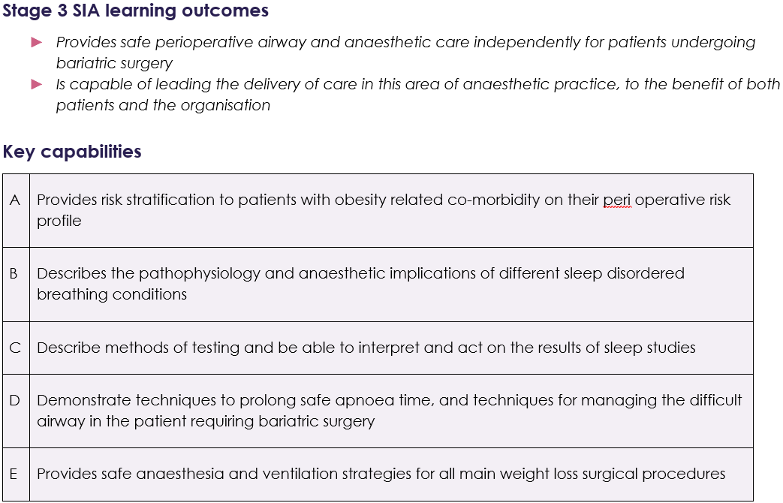

Examples of evidence

Experience and logbook:
- experience of a range of bariatric surgical procedures
- pre-operative assessment of patients planned for bariatric surgery including use of different risk scoring systems and indications for further investigation.

Supervised Learning Events (SLEs) can be used to demonstrate:
- assessment and management of cases with high BMI including those undergoing obesity surgery
- understanding of the different factors relevant to airway management in these patients
- evaluation of sleep studies and their impact on the perioperative management including indications for referral
- assessment and management of complications associated with high Body Mass Index (BMI) such as OSA and VTE management
- use of TIVA in management of bariatric patients including discussion of the different models involved.

Personal Activities and Personal Reflections may include:
- national and international meetings related to anaesthesia for bariatric surgery and specialist societies
- presentation at relevant meeting eg abstract or free paper
- development of guidelines and policies related to management of patients with high BMI
- leadership of QI projects related to patients with high BMI undergoing surgical procedures
- leadership training.

Other evidence:
- satisfactory MSF.

Suggested supervision level
- 4 - should be able to manage independently with no supervisor involvement (although should inform consultant supervisor as appropriate to local protocols).

Cross links with other domains and capabilities
- all non-clinical domains of learning
- Perioperative Medicine and Health Promotion
- General Anaesthesia

Anaesthesia for Cardiac Surgery
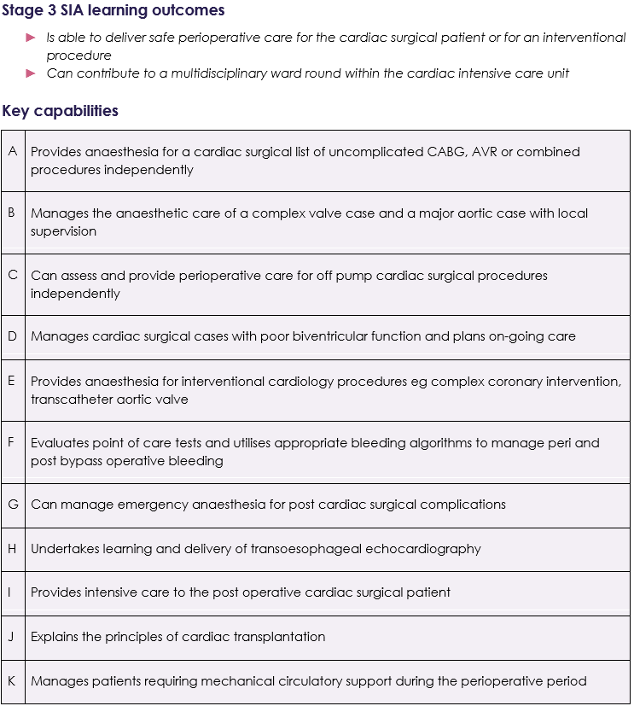

Examples of evidence

Experience and logbook:
- appropriate preoperative assessment whether in a preoperative clinic or ward based assessment with interpretation of the relevant preoperative investigations to plan appropriate care for the patient
- logbook should demonstrate a range of cardiac cases - elective, urgent and emergency including coronary artery bypass surgery, valve surgery, and surgery on the thoracic aorta. Some time should be spent spent in the cardiac catheter suite to support minimally invasive and structural work
- centres that do not have access to transplant or ECMO services should encourage their trainees to seek supernumerary visits to other departments
- intraoperative care should include appropriate use of inotropes and vasopressors and management of cardiac surgical bleeding supported by Point of Care analysis
- anaesthetists in training should start to develop trans-oesophageal echocardiography hands on skills and interpretation of basic images.
- participate and go on to lead a cardiac intensive care ward round with the relevant communications to surgeons, senior nurses, and other members of the MDT and escalation or de-escalation of care to patients which may include haemofiltration, percutaneous tracheostomy and referral to a specialist unit.

Supervised Learning Events (SLEs) can be used to demonstrate:
- understanding and discussion of the principles of safe cardiopulmonary bypass
- effective communication triad between lead surgeon, lead anaesthetist and clinical perfusionist
- advanced vascular access - pulmonary artery catheter
- basic TOE logbook with attendance at appropriate course
- delivery of anaesthesia with distant supervision for an elective aortic valve replacement, CABG or combination of both
- returning a patient to theatre for bleeding independently and escalate the appropriate haemorrhage management
- participation in patient MDT in preparation for theatre and/or Cardiac ICU.

Personal Activities and Personal Reflections may include:
- national and international meetings related to anaesthesia for cardiac surgery
- presentation at relevant meeting eg abstract or free paper
- development of guidelines and policies related to management of patients for cardiac surgery
- leadership of QI projects related to anaesthesia for cardiac surgery
- leadership training.

Other evidence:
- satisfactory MSF.

Suggested supervision level
- 3 - supervisor on call from home for queries able to provide directions via phone or non-immediate attendance.

Cross links with other domains and capabilities
- all non-clinical domains of learning
- Perioperative Medicine and Health Promotion
- General Anaesthesia
- Intensive Care

Anaesthesia for Complex Orthopaedic Surgery
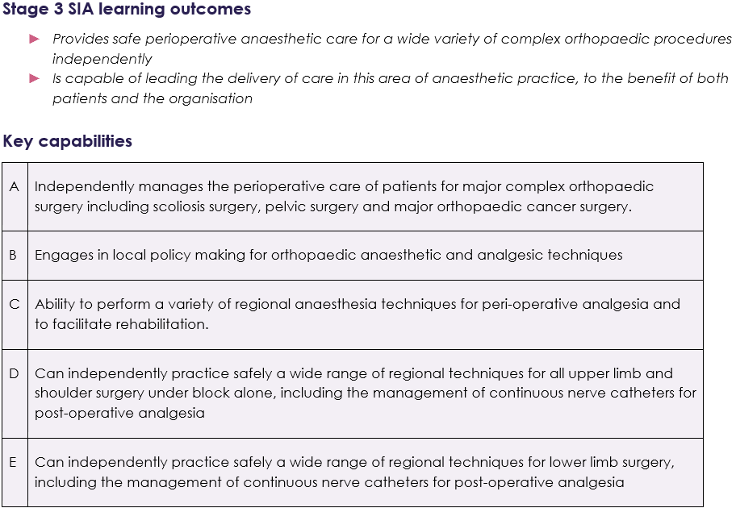

Examples of evidence

Experience and logbook:
- preoperative clinic based assessment and preparation for surgery of patients
- a wide range of cases including patients for revision arthroplasty, major complex oncological resections and scoliosis/oncological spinal surgery.

Supervised Learning Events (SLEs) can be used to demonstrate:
- preoperative assessment for high-risk orthopaedic cases
- ability to manage major haemorrhage
- ability to provide safe and effective postoperative analgesic options
- effective list management.

Personal Activities and Personal Reflections may include:
- national and international meetings related to anaesthesia for complex orthopaedic surgery
- presentation at relevant meeting eg abstract or free paper
- development of guidelines and policies
- leadership of QI projects related to anaesthesia for complex orthopaedic surgery
- leadership training.

Other evidence:
- satisfactory MSF.

Suggested supervision level
4 - should be able to manage independently with no supervisor involvement (although should inform consultant supervisor as appropriate to local protocols).

Cross links with other domains and capabilities
- all non-clinical domains of learning
- Perioperative Medicine and Health Promotion
- General Anaesthesia
- Regional Anaesthesia

Anaesthesia for Hepato-Pancreato-Biliary Surgery
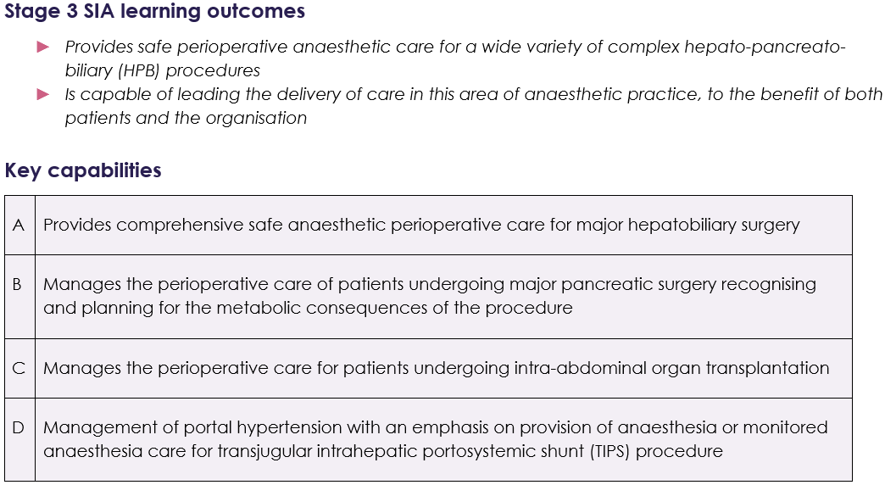

Examples of evidence

Experience and logbook:
- attendance at hepatobiliary pre-assessment clinic, assessing patients for major cancer work affecting the liver and pancreas
- attend theatre - deliver anaesthesia for a wide range of cases including lap and open liver resections, pancreatic surgery – PPPD, Whipples, distal pancreatectomy and splenectomy; understand the differences in techniques and the risks associated for the patient
- gain an understanding of neuroendocrine and adrenal tumours, such as phaeochromocytomas where experience is available
- liver transplantation – risks/ benefits/assessment – attendance at inpatient and outpatient assessment clinics and MDT
- attendance at monthly hepatobiliary and liver MDT
- assess patients for surgery secondary to liver transplants – hernias/ biliary reconstruction
- understand thrombo-elastography (TEG) and the management of major haemorrhage
- vascular access / Lidco / TOE / Pulmonary artery floatation catheters.

​​​​Supervised Learning Events (SLEs) can be used to demonstrate:
- pre-operative assessment for hepatobiliary patients including high risk cases
- understanding and discuss of the techniques used for different operations and understand why they are used
- delivery of anaesthesia for simple liver resections and pancreatic surgery independently
- discussion of the management of neuro-endocrine tumours and adrenal patients where experience is available
- management of parts of a liver transplant operation based on skillset and abilities
- planning post-operative analgesia based on the operation
- observed practice of practical skills – TEG interpretation/ venous access/ thoracic epidurals.

Personal Activities and Personal Reflections may include:
- national and international meetings related to anaesthesia for HPB surgery
- presentation at relevant meeting eg abstract or free paper
- development of guidelines and policies related to management of patients for HPB surgery
- leadership of QI projects related to anaesthesia for HPB surgery
- leadership training
- participation in audit and/or research in the liver unit.

Other evidence:
- satisfactory MSF.

Suggested supervision level
- 3 - supervisor on call from home for queries able to provide directions via phone or non-immediate attendance.

Cross links with other domains and capabilities
- all non-clinical domains of learning
- Perioperative Medicine and Health Promotion
- General Anaesthesia
- Intensive Care

Anaesthesia for Major General Surgery
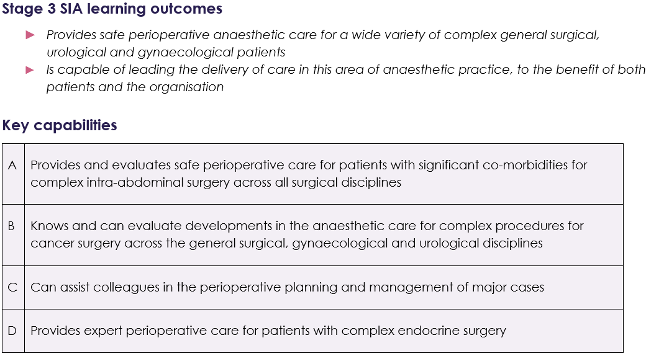

Examples of evidence

Experience and logbook:
- pre-operative assessment clinics including risk assessment for patients undergoing major abdominal surgery and planning for high risk patients
- involvement with pre-operative surgical preparation pathways such as enhanced recovery
- experience of broad range of elective and emergency major procedures in general, gynaecological and urological surgery including major cancer and intra-abdominal endocrine surgery such as adrenal gland and carcinoid tumours.

Supervised Learning Events (SLEs) can be used to demonstrate:
- involvement of multi-disciplinary team in shared decision making for high risk patients undergoing major procedures
- pre-operative preparation of patients with endocrine abnormalities for example thyroid and parathyroid disease
- assessment and peri-operative management of patient undergoing elective major intra-abdominal cancer surgery
- analgesic strategies and techniques for patients undergoing intra-abdominal procedures
- management of patients for minimally invasive abdominal and pelvic surgery including effects of positioning for prolonged laparoscopic procedures.

Personal Activities and Personal Reflections may include:
- national and international meetings related to anaesthesia for major general surgery
- presentation at relevant meeting eg abstract or free paper
- development of guidelines and policies related to management of patients for major general surgery including pre-operative preparation and enhanced recovery programmes
- leadership of QI projects related to anaesthesia for major general surgery
- leadership training.

Other evidence:
- satisfactory MSF.

Suggested supervision level
- 4 - should be able to manage independently with no supervisor involvement (although should inform consultant supervisor as appropriate to local protocols).

Cross links with other domains and capabilities
- all non-clinical domains of learning
- Perioperative Medicine and Health Promotion
- General Anaesthesia
- Intensive Care

Anaesthesia for Neurosurgery
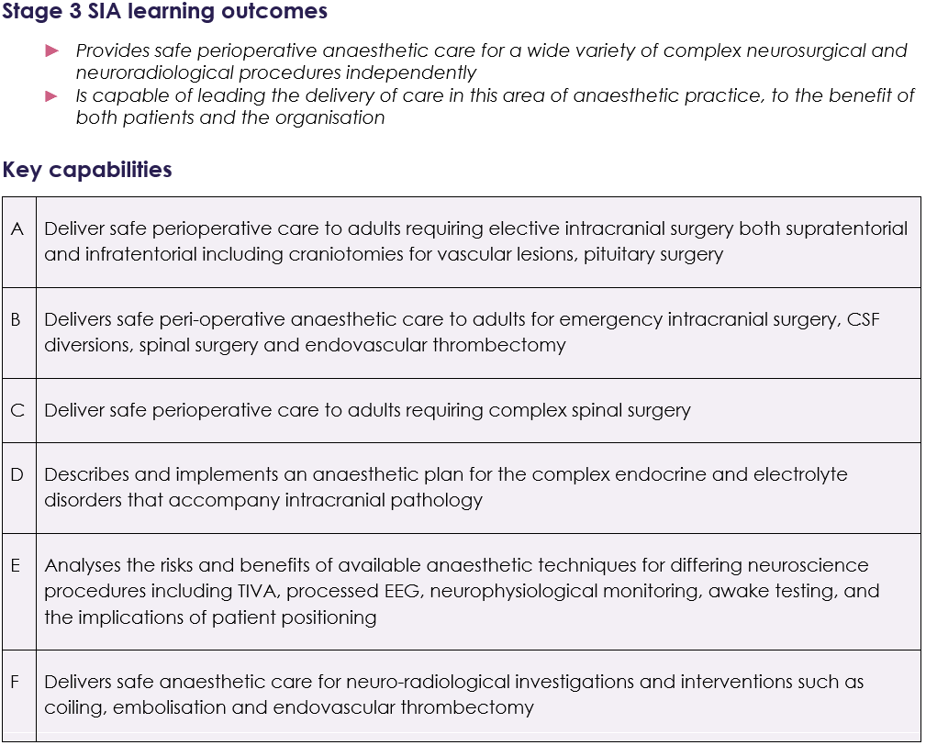

Examples of evidence

Experience and logbook:
- preoperative clinic experience and the assessment and optimisation of patients presenting for elective neurosurgical procedures
- a wide range of elective cases, which may include simple and complex spinal procedures, neurovascular procedures (surgical and interventional neuro-radiological), other neuroimaging eg MRI, trans-sphenoidal cases, neuro-oncology, functional neurosurgery, paediatric neurosurgery and may include awake craniotomies
- Perioperative management of emergency neurosurgical presentations which may include decompressive craniectomy, emergency craniotomies, CSF diversion procedures, emergency spinal surgery, urgent neuro-radiological procedures such as aneurysm coiling or mechanical thrombectomy, and management of the patient with traumatic brain or spinal injury
- experience may also include neuro-critical care, and the resuscitation and transfer of patients with neurological injury or pathology.

Supervised Learning Events (SLEs) can be used to demonstrate:
- management of any of the above cases
- effective list management of an elective or emergency neurosurgical or neuroradiology session
- pre-operative assessment and optimisation of patients with complex neurological needs, for example patients with movement disorders, complex epilepsy, endocrine sequelae of pituitary disease, or with medical comorbidities, which may complicate neurosurgery eg conditions requiring anticoagulation
- appreciation of the balance between risks and benefits of neurosurgery and anaesthesia in complex or frail patients and ability to work with patients, their families and multidisciplinary colleagues to plan best care
- ability to safely position patients in a variety of positions for surgery and with different equipment, eg prone or park bench positioning, use of Allan table or stereotactic or robotic head-frames
- advanced airway management skills relevant to neuro-anaesthesia eg awake intubation techniques, video-laryngoscopy
- ability to adapt anaesthetic technique to facilitate neurophysiological monitoring, eg TIVA anaesthesia and intraoperative neuro-monitoring, awake cranial procedures, intra-operative EEG monitoring.

Personal Activities and Personal Reflections may include:
- national and international meetings related to neuro-anaesthesia
- presentation at relevant meeting eg abstract or free paper
- development of neuro-anaesthetic or neuro-critical care guidelines and policies
- leadership of QI projects related to neuro-anaesthesia
- attendance at neurosurgical or neuro-radiological MDT meetings
- eLearning relevant to neuro-anaesthesia and neurological conditions
- sessions with radiology learning interpretation of neuroimaging
- participation and leadership in local/regional/national neuro-anaesthesia teaching
- simulation in neuro-anaesthesia and related emergencies.

Other evidence:
- satisfactory MSF.

Suggested supervision level
- 4 - should be able to manage independently with no supervisor involvement (although should inform consultant supervisor as appropriate to local protocols).

Cross links with other domains and capabilities
- all non-clinical domains of learning
- Perioperative Medicine and Health Promotion
- General Anaesthesia
- Intensive Care

Anaesthesia for Ophthalmic Surgery
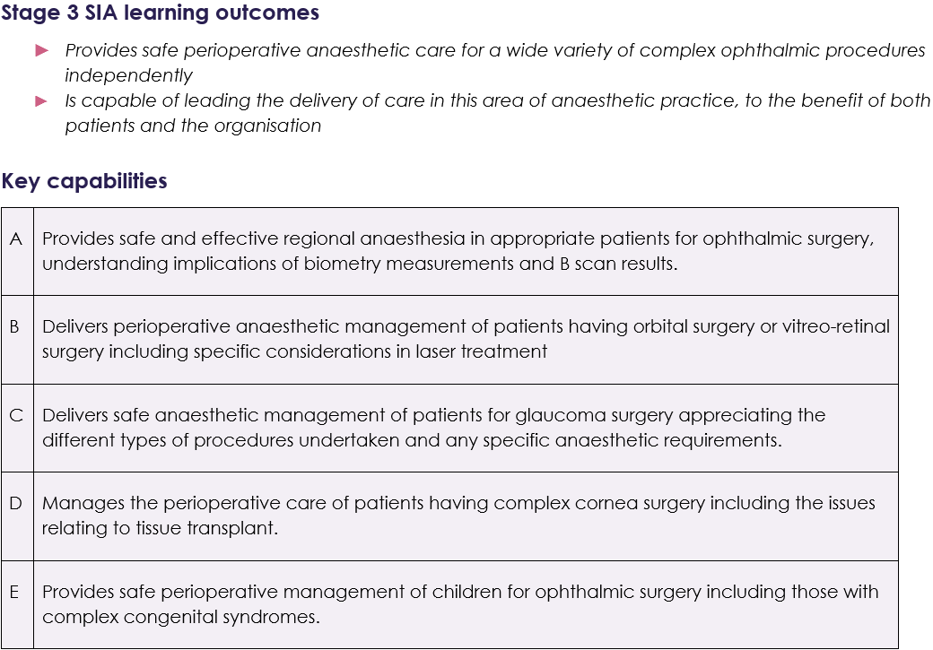

Examples of evidence

Experience and logbook:
- experience of a wide range of elective and emergency ophthalmic procedures including those in children.

Supervised Learning Events (SLEs) can be used to demonstrate:
- assessment and management of cases as detailed in key capabilities
- management of intra-ocular pressure
- implications of use of laser in ophthalmic theatres
- ability to provide ophthalmic regional anaesthesia
- liaison with surgical team in the management of complex patients
- safe sedation for ophthalmic surgery under local anaesthesia
- management of ophthalmic trauma including open globe injuries.

Personal Activities and Personal Reflections may include:
- national and international meetings related to ophthalmic anaesthesia
- presentation at relevant meeting eg abstract or free paper
- teaching and training junior staff; this can include the use of part simulators for ophthalmic regional anaesthesia
- development of guidelines and policies related to ophthalmic anaesthesia

- leadership of QI projects related to ophthalmic anaesthesia
- leadership training.

Other evidence:
- satisfactory MSF.

Suggested supervision level
- 4 - should be able to manage independently with no supervisor involvement (although should inform consultant supervisor as appropriate to local protocols).

Cross links with other domains and capabilities
- all non-clinical domains of learning
- Perioperative Medicine and Health Promotion
- General Anaesthesia
- Regional Anaesthesia

Anaesthesia for Patients with Complex Airway
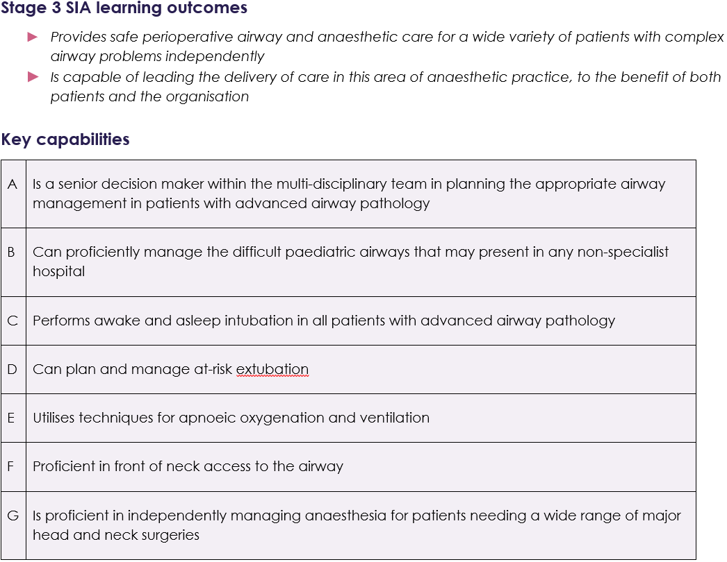

Examples of evidence

Experience and logbook:
- pre-operative clinic based assessment and multi-disciplinary planning for the suitability of surgery of patients with complex head and neck pathology like cancer, infection and congenital or acquired anatomical deformities
- range of experience in theatres including ENT and head and neck surgery and specialist paediatric lists.

Supervised Learning Events (SLEs) can be used to demonstrate:
- pre-operative assessment and management of complex head and neck surgery patient
- leadership of multi-disciplinary planning for patients with complex airways
- practical procedures such as:
- video-laryngoscope assisted intubations using both MAC and hyper angulated blades
- pre-operative nasendoscopy
- awake and asleep fibre-optic intubation
- awake bronchoscopies
- front of neck access techniques: ultrasound guided, mannequin, cadaver
- jet ventilation (tube-less surgeries)
- apnoeic oxygenation techniques
- ability to interpret investigations like CT head & neck and CT chest to aid the planning of complex airway management
- use of innovative techniques for complex airway management
- management of potentially difficult paediatric airway in conditions such as croup, epiglottitis, bleeding tonsil.

Personal Activities and Personal Reflections may include:
- national and international meetings related to management of complex airways, for example Difficult Airway Society meetings
- difficult airway training courses
- presentation at relevant meeting ie abstract or free paper
- development of guidelines and policies related to airway management
- leadership of QI projects related to airway management
- involvement with local/regional educational programs for teaching airway skills
- leadership training
- attendance at MDT ENT - radiology teaching sessions.
- attendance at ENT clinics (nasendoscopy experience)
- attendance at respiratory bronchoscopy sessions.

Other evidence:
- satisfactory MSF.

Suggested supervision level
- 4 - should be able to manage independently with no supervisor involvement (although should inform consultant supervisor as appropriate to local protocols).

Cross links with other domains and capabilities
- all non-clinical domains of learning
- General Anaesthesia

Anaesthesia for Plastic Surgery and Burns Management
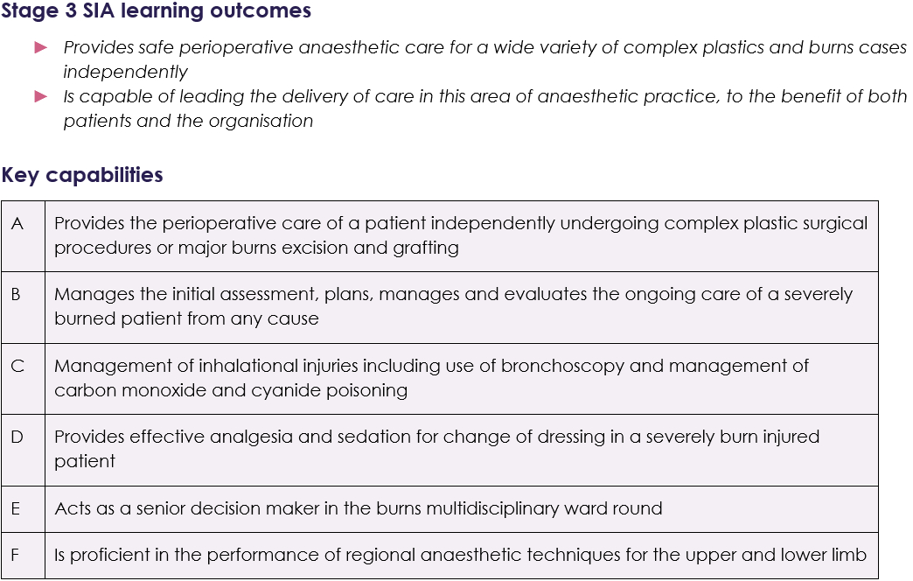

Examples of evidence

Experience and logbook:
- experience of a wide range of elective and emergency plastic surgery and burns procedures including those in children
- experience in the emergency management of major burns injuries.

Supervised Learning Events (SLEs) can be used to demonstrate:
- emergency assessment, resuscitation, and ongoing management of patients with major burn injury including airway management and organ support
- management of fluid resuscitation following major burn injury
- bronchoscopy assessment of inhalational lung injury
- perioperative management of patients undergoing major burns excision and grafting
- management of dressing changes including different analgesia and sedation techniques
- ICU management of patients with major burn injury requiring multi organ support
- perioperative management of patients undergoing free flap surgery
- perioperative management of patients undergoing reconstructive surgery
- management of major haemorrhage during major burns/plastics surgery including blood conservation techniques
- perioperative management of emergency plastic surgery cases including the use of regional techniques.

Personal Activities and Personal Reflections may include:
- national and international meetings related to plastic surgery and burns management
- attendance at regional education meetings
- presentation and discussion of cases at local, regional, and national network meetings
- burns specific resuscitation courses
- development of guidelines and policies for management of Burns
- leadership of QI projects related to plastic surgery and burns management
- leadership training
- simulation training.

Other evidence:
- satisfactory MSF.

Suggested supervision level
- 4 - should be able to manage independently with no supervisor involvement (although should inform consultant supervisor as appropriate to local protocols).

Cross links with other domains and capabilities
- all non-clinical domains of learning
- Perioperative Medicine and Health Promotion
- General Anaesthesia
- Resuscitation and Transfer
- Pain
- Intensive Care

Anaesthesia for Thoracic Surgery
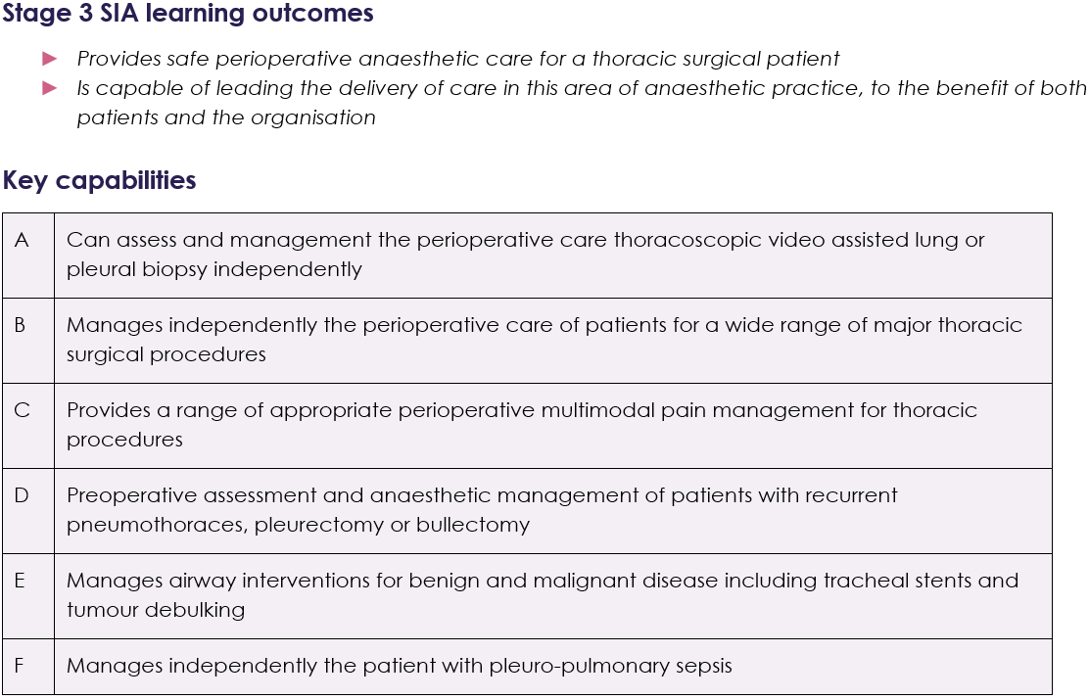

Examples of evidence

Experience and logbook:
- preoperative clinic based assessment of suitability and preparation for surgery of patients with diseases of the lungs, pleura, mediastinum and chest wall
- a wide range of cases including patients undergoing lung resection, mediastinal surgery, and pleural surgery
- management of thoracic trauma including haemothorax and pneumothorax
- management of patients undergoing tracheal surgery.

Supervised Learning Events (SLEs) can be used to demonstrate:
- pre-operative assessment for thoracic surgical patients including high risk cases
- understanding of techniques for airway management during tracheal surgery
- ability to manage patients undergoing lung resection, pleural surgery, mediastinal surgery and diagnostic procedures
- management of single lung ventilation and its consequences
- ability to achieve lung isolation with double lumen tubes and bronchial blockers
- ability to provide safe and effective postoperative analgesia
- effective list management.

Personal Activities and Personal Reflections may include:
- national and international meetings related to thoracic anaesthesia
- presentation at relevant meeting eg abstract or free paper
- development of guidelines and policies
- leadership of QI projects related to thoracic anaesthesia
- leadership training.

Other evidence:
- satisfactory MSF.

Supervision level
- 4 - should be able to manage independently with no supervisor involvement (although should inform consultant supervisor as appropriate to local protocols).

Cross links with other domains and capabilities
- all non-clinical domains of learning
- Perioperative Medicine and Health Promotion
- General Anaesthesia
- Regional Anaesthesia
- Pain

Anaesthesia for Vascular Surgery
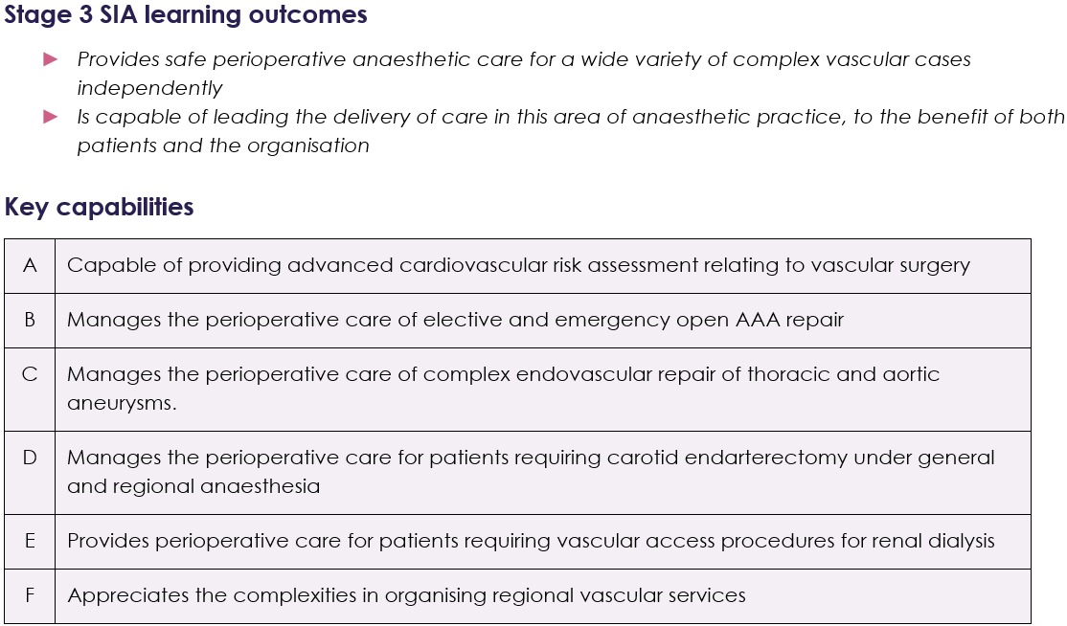

Examples of Evidence

Experience and logbook:
- pre-operative assessment clinics including evaluation of cardiovascular risk
- broad experience of elective and emergency vascular surgery including carotid arterial procedures, aortic surgery, aorto-iliac occlusive disease procedures.

Supervised Learning Events (SLEs) can be used to demonstrate:
- perioperative care of high-risk patient undergoing vascular surgery
- involvement of multi-disciplinary team in shared decision making for high-risk surgery
- regional anaesthesia for vascular procedures including techniques for carotid endarterectomy
- management of major haemorrhage during emergency vascular surgery including blood conservation techniques
- ability to use specific techniques during anaesthesia to minimise effect of surgery such as spinal cord protection and maintenance of renal function
- intra-operative monitoring techniques for vascular procedures including cardiovascular and neurophysiological monitoring
- management of complications relating to carotid surgery
- assessment and management of patients with ruptured abdominal aortic aneurysm.

Personal Activities and Personal Reflections may include:
- national and international meetings related to vascular anaesthesia
- presentation at relevant meeting eg abstract or free paper
- development of guidelines and policies
- leadership of QI projects related to vascular anaesthesia
- leadership training.

Other evidence:
- satisfactory MSF.

Supervision level
- 4 - should be able to manage independently with no supervisor involvement (although should inform consultant supervisor as appropriate to local protocols).

Cross links with other domains and capabilities
- all non-clinical domains of learning
- Perioperative Medicine and Health Promotion
- General Anaesthesia
- Resuscitation and transfer
- Pain
- Intensive Care

Anaesthesia in Resource Poor Environments
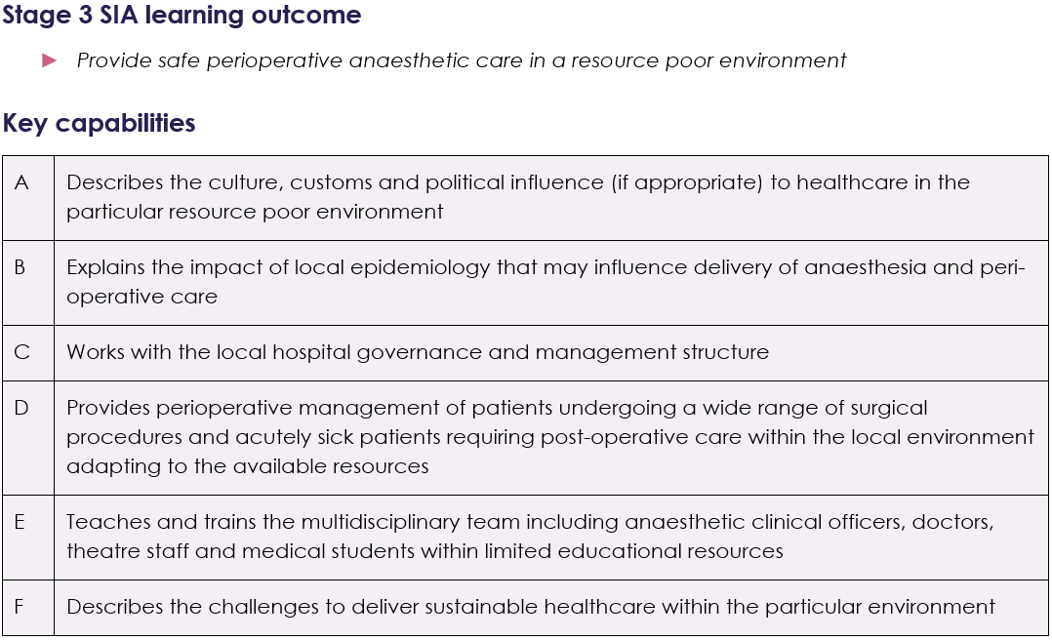

Examples of Evidence

Experience and logbook:
- logbook demonstrating use of appropriate regional or general techniques, for resource limited environment, of a wide range of patients undergoing elective or emergency surgery
- logbook evidence of experience managing anaesthesia particularly in obstetric, trauma and paediatric patients
- experience in delivering multidisciplinary team teaching and clinical anaesthesia in resource poor environment.

Supervised Learning Events (SLEs) can be used to demonstrate:
- ability to manage patients using draw-over or hybrid anaesthesia machine, ketamine anaesthesia, and resource appropriate regional or local techniques
- safe pre-operative management of patients presenting with undiagnosed or poorly treated chronic conditions
- ability to manage the perioperative care of emergency cases including the post-operative level 2 or 3 care with available local resources, including referral
- inclusive approach to list management, leading a multidisciplinary team of mixed abilities and language
- understanding of the cultural and political influences on low resource health systems
- a systematic approach to theories of change and principles of sustainable development.

Personal Activities and Personal Reflections may include:
- attendance at national and international meetings or courses related to world anaesthesia, including presenting/speaking
- development of guidelines and policies alongside local counterparts
- involvement in teaching opportunities for the multidisciplinary team
- training focused on delivery of education in low resource settings (eg SAFE)
- development of skills in a foreign language
- understanding of the impact conscious and unconscious biases on delivery of healthcare and education to low resource settings
- involvement in organisations promoting safe global anaesthesia (e.g. World Anaesthesia Society, RCoA Global Partnerships, GASOC, MSF)
- Diploma in Tropical Medicine and Hygiene
- Global Health Medicine certification (PGCert, Dip or MSc)
- Diploma in the Medical Care of Catastrophes.

Other evidence:
- satisfactory MSF.

Suggested supervision level
- 4 - should be able to manage independently with no supervisor involvement (although should inform consultant supervisor as appropriate to local protocols).

Cross links with other domains and capabilities
- all non-clinical domains of learning
- Perioperative Medicine and Health Promotion
- General Anaesthesia
- Regional Anaesthesia
- Pain

Education and Training
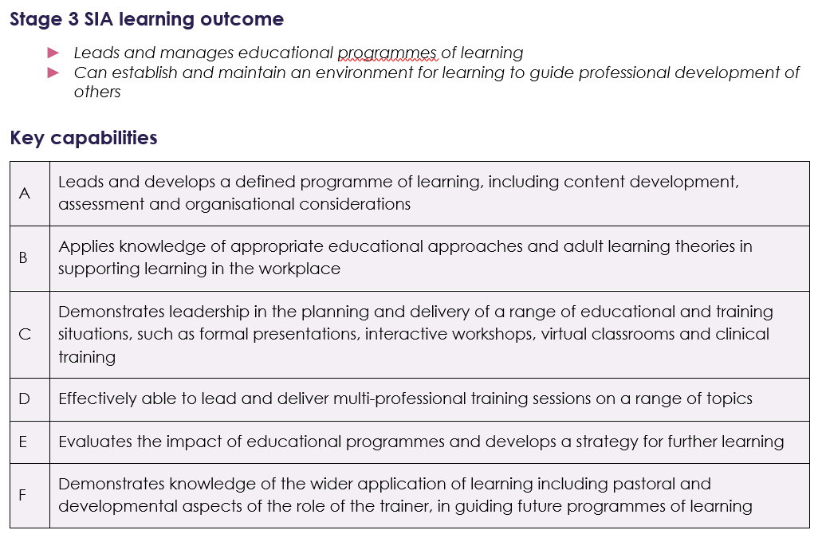

Examples of Evidence

Experience and logbook:
- Experience beyond the Learning Outcomes of Stage 3
- If clinical work is done during this time, then cases should be documented in the logbook

Supervised Learning Events (SLEs):
- should be completed as part of any clinical work undertaken and linked to relevant key capabilities in Stage 3
- evidence of SLEs completed as the trainer, notably the feedback comments
- evidence of the use of different feedback methods and tools, adapted to different learning environments and clinical training
- evidence of engagement in mentoring and pastoral development as a trainer in the workplace, throughout the programme of learning

Personal Activities and Personal Reflections may demonstrate:
- reflective portfolio of education and training opportunities
- leadership in the planning of educational meeting or regional training programme, including appropriate evaluation
- evidence of the expert application of different teaching materials in a variety of settings in the workplace
- experience of undertaking a Learning Needs Assessment for an individual or group
- experience of recognising and appropriately supporting individuals who may not be making adequate progress in the workplace
- experience of the use of different feedback mechanisms
- use of Simulations Based Educational approaches and the role of psychological safety and debriefing strategies
- contribution to educational policy at local or national levels
- presentation of work at educational meeting or conferences, including poster presentation, workshops or oral presentation
- additional educational qualifications (such as GIC, PG cert, Fellow of HEA or diploma) – it is important to note that the SIA must include practical application of the learning
- evidence of involvement in educational research
- critical analysis of Educational literature and application of up-to-date educational knowledge.

Other evidence:
- satisfactory MSF

Supervision level
- not applicable

Cross links with other domains and capabilities
- Stage 3 non-clinical domains
- Stage 3 clinical key capabilities where appropriate.

Management and Professional and Regulatory Requirements
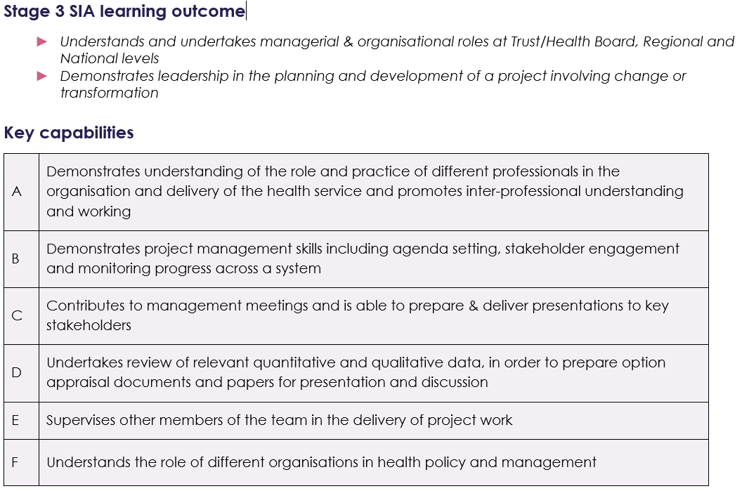

Examples of Evidence

Experience and logbook:
- experience beyond the Learning Outcomes of Stage 3
- experience of managing service changes and/or transformation projects
- if clinical work is done during this time, then cases should be documented in the logbook.

Supervised Learning Events (SLEs):
- should be completed as part of any clinical work undertaken and linked to relevant Key Capabilities in Stage 3
- Utilise SLEs where appropriate to gain feedback on activities as part of management portfolio.

Personal Activities and Personal Reflections may demonstrate:
- portfolio of presentations of work undertaken with stakeholders
- experience of managing project performance including governance frameworks and Quality Assurance processes
- experience of different frameworks to assess performance and reporting mechanisms within organisations
- engagement with different roles within Trust/Health Board, national and regional structures through attendance at meetings
- experience of exploring the different ways patients/carers and the wider public are involved in informing service development and planning or policy
- attendance at leadership and management training sessions including up-to-date approaches and different methodologies as part of change management
- experience of chairing and leading meetings where appropriate
- attendance and reflection on local, regional, national, and international (where appropriate) meetings related to management in healthcare
- written report of project including executive summary and recommendations
- presentation of project work and summary of findings and recommendations
- development of implementation plan
- presentation of project findings in the form of posters, abstracts, and presentations at an appropriate meeting.

Other evidence:
- satisfactory MSF

Supervision level
- not applicable

Cross links with other domains and capabilities
- Stage 3 non-clinical domains
- Stage 3 clinical key capabilities where appropriate.

Military Anaesthesia
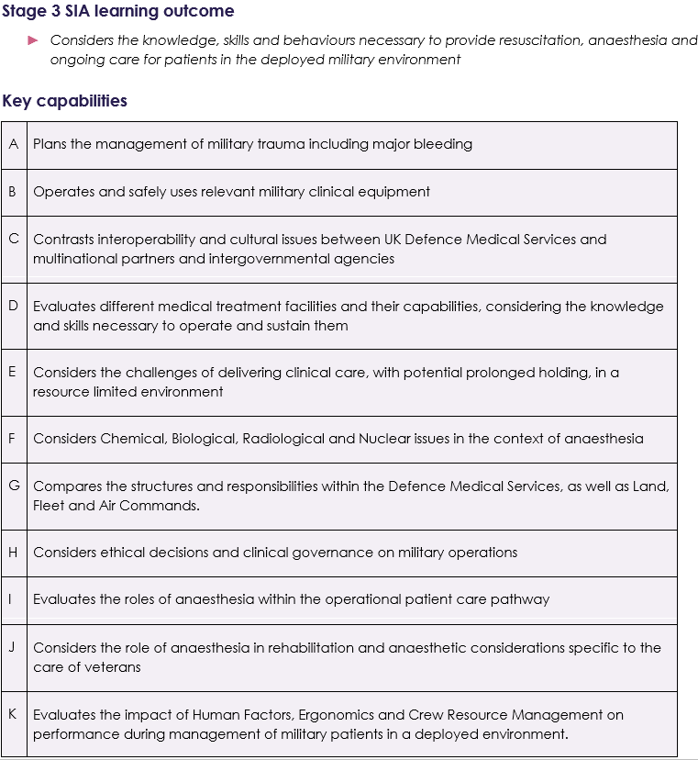

Examples of Evidence

Experience and logbook:
- a wide range of cases including major trauma, management of haemorrhage and massive blood transfusion, regional anaesthesia (particularly in trauma) and inter-hospital critical care transfers.

Supervised Learning Events (SLEs) can be used to demonstrate:
- ability to manage the resuscitation and anaesthesia requirements of patients suffering major trauma
- the management of resuscitation in major haemorrhage including massive blood transfusion
- ability to use deployed anaesthetic equipment
- understanding of the operational patient care pathway.

Personal Activities and Personal Reflections may include:
- national and international meetings related to military anaesthesia
- presentation at relevant meeting eg abstract or free paper
- development of guidelines and policies
- leadership of QI projects related to military anaesthesia
- leadership training
- simulation training
- attending the Military Operational Surgical Team Training (MOSTT) Course, the Defence Anaesthesia Simulation Course (DASC), the Medical Emergency Response Team (MERT) Course and the CBRN Clinical Course
- deployment on operations and exercises in Land, Air and Maritime Medical Treatment Facilities (MTFs).

Other evidence:
- satisfactory MSF.

Supervision level
- 4 - should be able to manage independently with no supervisor involvement (although should inform consultant supervisor as appropriate to local protocols).

Cross links with other domains and capabilities
- all non-clinical domains of learning
- Perioperative Medicine and Health Promotion
- General Anaesthesia
- Intensive Care

Obstetric Anaesthesia
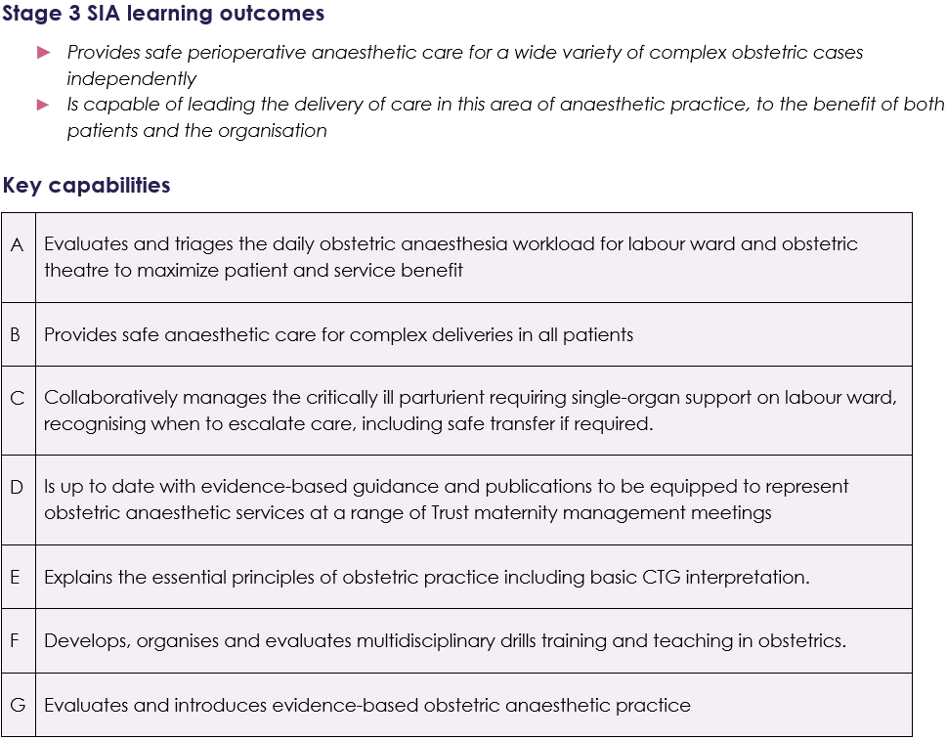

Examples of evidence

Experience and logbook:
- experience in obstetric unit with wide range of cases including mothers with complex medical needs and high dependency unit caring for obstetric patients
- exposure to multi-disciplinary team (MDT)meetings and obstetric management meetings.

Supervised Learning Events (SLEs) can be used to demonstrate:
- pre-operative assessment for high-risk cases
- understanding and knowledge of difficult airway management in obstetric cases
- management of obstetric emergencies
- management of critically ill parturients
- ability to manage and provide safe and effective anaesthesia and analgesia for obstetric patients in the elective and emergency setting
- elective Caesarean section list management
- labour ward management of workload
- effective management of high-risk patients
- management of non-obstetric surgery in pregnancy
- leading ward round of high dependency unit obstetric patients
- leadership and delegation by leading anaesthetic handover, managing elective list and delivery suite workload
- involvement with obstetric patients with complex medical needs eg congenital cardiac diagnoses
- safeguarding issues in obstetric patients with learning difficulties, mental health issue or under age pregnancy
- ethical dilemmas eg consent for delivery and anaesthetic in pregnant patients with severe mental health issue
- perioperative assessment and MDT discussion for pregnant women with complex medial background.

Personal Activities and Personal Reflections may include:
- attending and leading high risk obstetric anaesthetic clinics to formulate management plans
- attending MDT meetings to plan patient care
- attending Obstetric management meetings
- shadowing members of the MDT to appreciate their roles eg Lead Labour Ward Midwife, Consultant Obstetrician
- teaching on PROMPT, BOAST, simulation courses
- attending CTG teaching
- attendance at joint obstetric specialist clinics eg cardiac/haematology
- supervision/mentorship of junior anaesthetists doing IACOA/stage 1 obstetric anaesthesia
- national and international meetings related to obstetric anaesthesia
- presentation at relevant meeting eg abstract or free paper
- development of guidelines and policies
- leadership of QI projects related to obstetric anaesthesia
- leadership training.

Other evidence:
- satisfactory MSF.

Supervision level
- 4 - should be able to manage independently with no supervisor involvement (although should inform consultant supervisor as appropriate to local protocols).

Cross links with other domains and capabilities
- all non-clinical domains of learning
- Perioperative Medicine and Health Promotion
- General Anaesthesia
- Regional Anaesthesia

Paediatric Anaesthesia
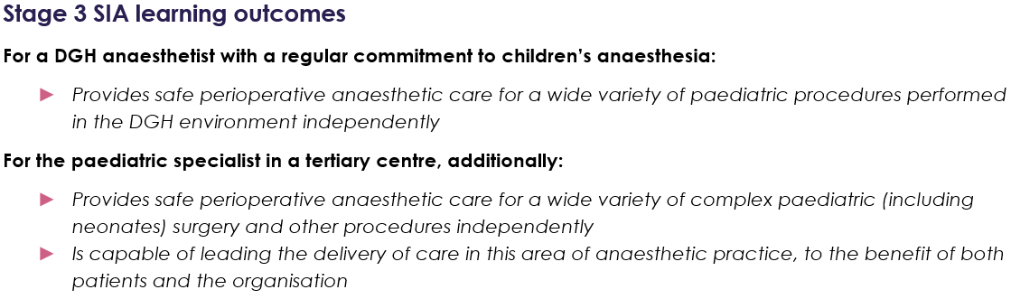
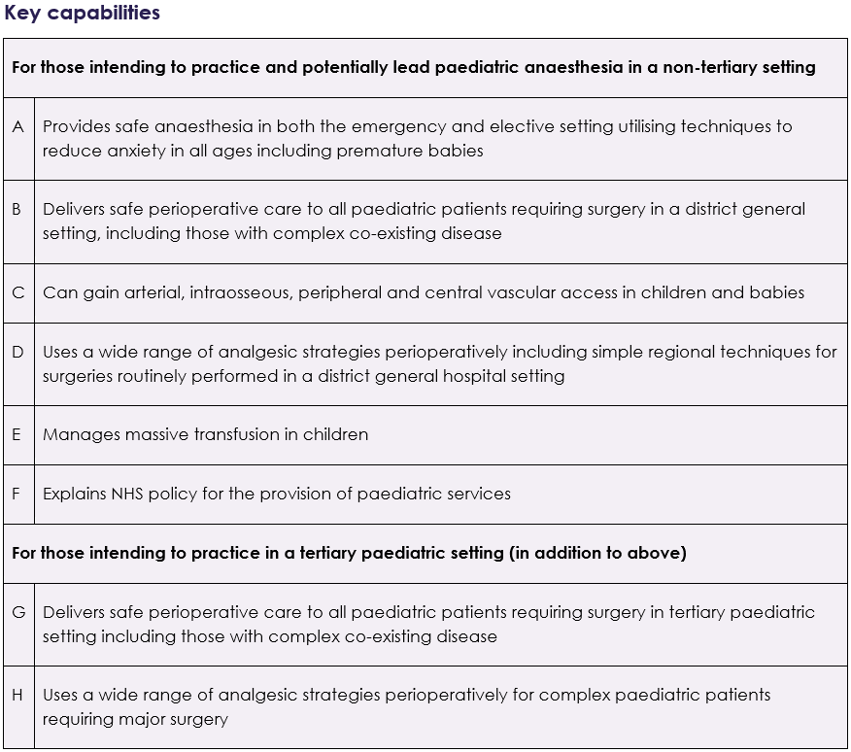

Examples of evidence

Experience and logbook:
- experience of a wide range of paediatric cases in an elective and emergency setting including paediatric trauma, emergency surgery and procedures such as laryngotracheobronchoscopy
- experience of neonatal anaesthesia
- resuscitation and stabilisation of the critically ill child.

Supervised Learning Events (SLEs) can be used to demonstrate:
- preoperative assessment including planning for induction of anaesthesia
- premedication and management of the anxious child
- neonatal anaesthesia including neonatal laparotomy
- management of post-operative analgesia in different age groups of child
- transfer and handover of the postoperative child to PICU
- indications and the practice of venous access in children
- regional anaesthesia in children.

Personal Activities and Personal Reflections may include:
- national and international meetings related to paediatric anaesthesia such as APAGBI annual meeting
- presentation at relevant meeting eg abstract or free paper
- development of guidelines and policies
- leadership of QI projects related to paediatric anaesthesia
- leadership training
- simulation training such as: Positive Outcome and Experience Management Strategies (POEMS), Managing Emergencies in Paediatric Anaesthesia (MEPA), Advanced Paediatric Life Support (APLS).

Other evidence:
- satisfactory MSF.

Supervision level
- 4 - should be able to manage independently with no supervisor involvement (although should inform consultant supervisor as appropriate to local protocols).

Cross links with other domains and capabilities
- all non-clinical domains of learning
- Perioperative Medicine and Health Promotion
- General Anaesthesia
- Pain

Pain Medicine
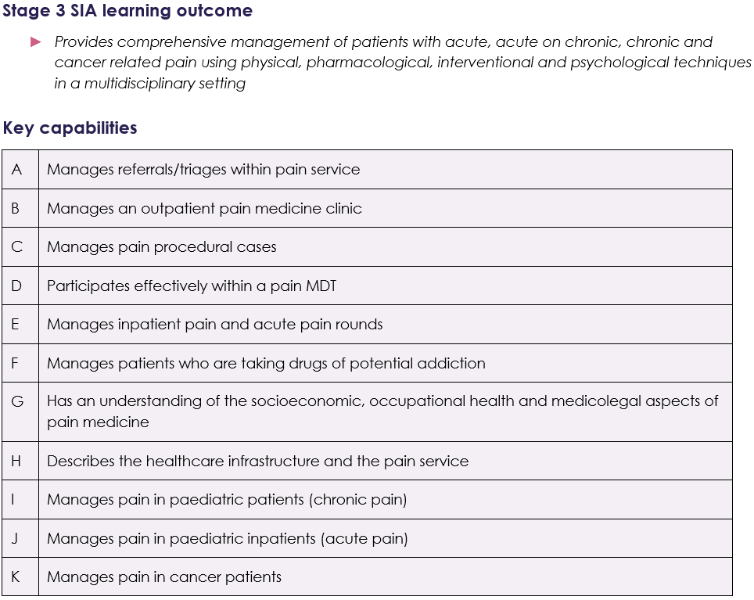

Examples of evidence

Experience and logbook:
- experience of multidisciplinary approaches to managing inpatient and outpatient pain in a variety of setting including inpatient ward rounds, outpatient clinics, advanced interventional techniques, pharmacological therapies and pain management programmes
- a wide range of clinical assessments and formulation of management plans for adults and children with acute, acute on chronic, chronic and cancer pain seen in both inpatient and outpatient clinic settings
- a wide range of pain management interventional procedures for acute, chronic and cancer pain using landmark, ultrasound and X-ray guided techniques.

Supervised Learning Events (SLEs) can be used to demonstrate:
- ability to work within a multidisciplinary pain team, collaborating with other specialties in primary and secondary care and allied health professions such as physiotherapy, occupational therapy, nursing and clinical psychology
- leading inpatient ward rounds and pain MDT
- comprehensive assessment of adults and children presenting with acute, acute on chronic and cancer pain, applying a biospsychosocial model of care.
- assessment of pain in complex scenarios, including those with cognitive impairment, limited verbal interaction and settings such as intensive care
- formulation and review of management plans for adults and children presenting with acute, acute on chronic and cancer pain
- recognition of patients with pain who have psychological problems and who require psychological evaluation, and the ability to apply established treatments for the management of psychological distress in those with pain
- management of complex patients with painful conditions, including those requiring coordinated care with other specialties and agencies, such as transition from paediatric to adult health and social services or those with drug dependences or mental health conditions
- pharmacological management of acute, acute on chronic, cancer and procedural pain in all age groups with different co-morbidities
- management of inpatient acute pain including postoperative pain; infusion pumps including PCAs, wound catheters, epidurals
- ability to plan, undertake and follow up interventional procedures for acute, chronic and cancer pain, including management of complications
- advanced interventional techniques for the management of cancer pain including but not exclusively, percutaneous cordotomy
- management of external and internal implantable drug delivery systems, both peripheral and central, for the management of cancer pain
- impact of pain on occupation and aspects of daily living; support structures for these patients
- assessment of pain in the context of neuromodulation
- referral criteria and process for patients requiring assessment and treatment by specialised pain services, eg neuromodulation, paediatric chronic pain
- management of outpatient clinics and pain intervention lists, including appropriate prioritisation of referrals.

Personal Activities and Personal Reflections may include:
- national and international courses or conferences related to Pain Medicine
- presentation at relevant meeting eg abstract or free paper
- development of guidelines and policies related to inpatient and outpatient pain
- leadership training and demonstration of ability to lead an inpatient acute pain service including supervision of nurse led services
- ability to lead multi-disciplinary pain meetings
- attend service development meetings
- deliver pain training to other professionals
- quality improvement and research projects in Pain Medicine.
- Courses/e-learning/personal reading: Role of pain management programmes, basic concepts of welfare benefits, Equality Act 2010, Mental Capacity Act, legal aspects of reasonable adjustments in context of occupation, role of social services in supporting patients with disability, Misuse of Drugs Act 1971 and Misuse of Drugs Regulations 2001, the Controlled Drugs (Supervision of Management and Use) Regulations 2013, guidance for healthcare professionals on drug driving.

Other evidence:
- satisfactory MSF
- option to take FFPMRCA exam.

Supervision level
- 4 - should be able to manage independently with no supervisor involvement (although should inform consultant supervisor as appropriate to local protocols).

Cross links with other domains and capabilities
- all non-clinical domains of learning
- Perioperative Medicine and Health Promotion
- General Anaesthesia
- Pain

Perioperative Medicine
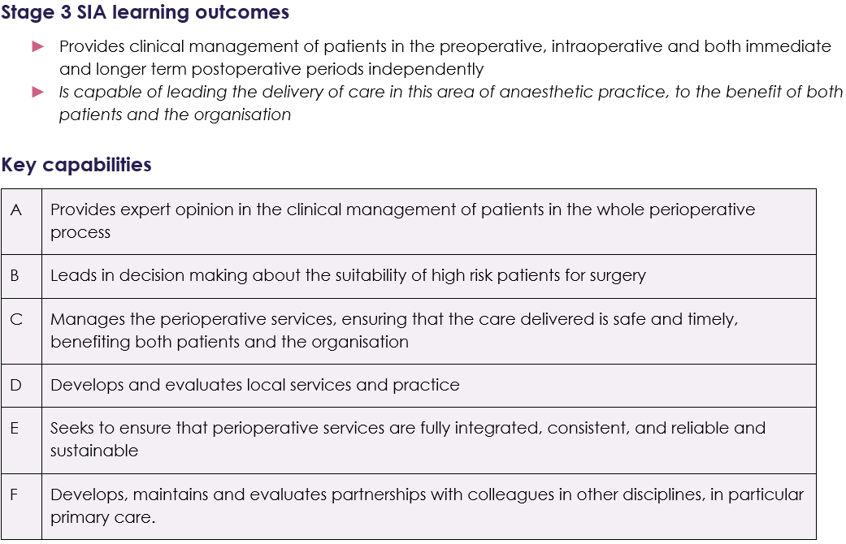

Examples of evidence

Experience and logbook:
- pre-operative assessment clinics, cardio-pulmonary exercise clinics, acute pain rounds, surgical multi-disciplinary team (MDT) meetings.

Supervised Learning Events (SLEs) can be used to demonstrate:
- assessment of risk and management of high-risk patients
- involvement of MDT and patient in shared decision making about high risk surgery
- pre-operative assessment and management of, for example: anaemia, anticoagulant medication, diabetes, obstructive sleep apnoea, pacemakers, hypertension
- assessment of frailty
- use of risk scoring tools and models of functional capacity
- perioperative analgesia management including regional techniques
- assessment of post-operative pain
- assessment and management of post-operative delirium

Personal Activities and Personal Reflections may include:
- national and international meetings related to perioperative medicine
- presentation at relevant meeting eg abstract or free paper
- development of guidelines and policies
- leadership of QI projects related to perioperative medicine
- leadership training
- experience of inpatient rounds such as orthogeriatrics
- attendance at medical clinics such as cardiology and respiratory.
- courses and eLearning: shared decision making.

Other evidence:
- satisfactory MSF.

Supervision level
- 4 - should be able to manage independently with no supervisor involvement (although should inform consultant supervisor as appropriate to local protocols).

Cross links with other domains and capabilities
- all non-clinical domains of learning
- Perioperative Medicine and Health Promotion
- General Anaesthesia
- Regional Anaesthesia
- Pain

Regional Anaesthesia
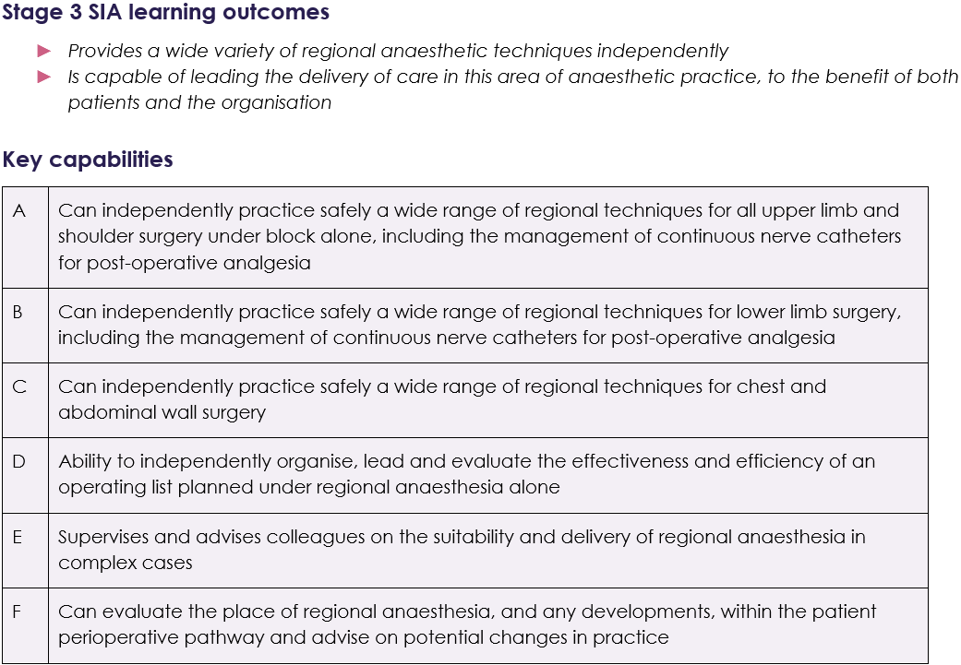

Examples of evidence

Experience and logbook:
- preoperative clinic based assessment of suitability and preparation for surgery of patients utilising regional anaesthesia
- a wide range of cases and techniques for awake and asleep surgical procedures.

Supervised Learning Events (SLEs) can be used to demonstrate:
- understanding and implementing comprehensive consent for regional techniques
- meticulous attention to wrong site block prevention based on national guidance
- ability to manage awake, sedated and general anaesthetic patients with a regional anaesthetic component
- ability to use ultrasound and needle techniques safely for a variety of procedures including nerve catheters
- ability to provide safe and effective postoperative analgesia through a variety of regional techniques
- management of regional anaesthesia lists.

Personal Activities and Personal Reflections may include:
- national and international meetings related to regional anaesthesia
- presentation at relevant meeting eg abstract or free paper
- development of guidelines and policies
- leadership of QI projects related to regional anaesthesia
- leadership training.

Other evidence:
- satisfactory MSF.

Supervision level
- 4 - should be able to manage independently with no supervisor involvement (although should inform consultant supervisor as appropriate to local protocols).

Cross links with other domains and capabilities
- all non-clinical domains of learning
- Perioperative Medicine and Health Promotion
- General Anaesthesia
- Regional Anaesthesia
- Pain

Research and Managing Data
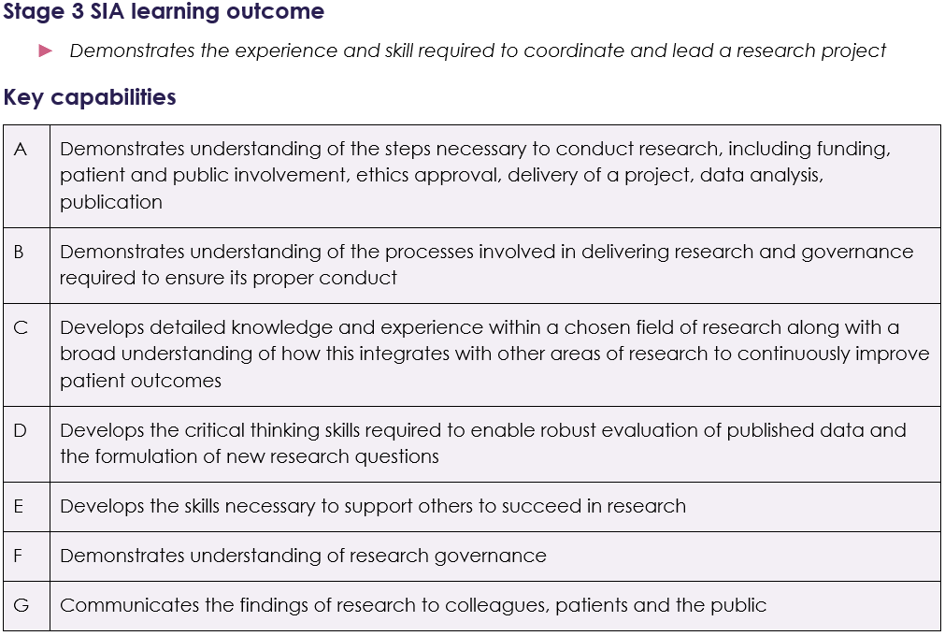

Examples of evidence

Experience and logbook:
- supervised research project that may be stand alone or form part of a larger project such as that for a higher degree (PhD, MD)
- if clinical work is done during the research time then cases should be documented in the log book.

Supervised Learning Events (SLEs):
- should be completed as part of any clinical work undertaken and linked to relevant Key Capabilities in Stage 3

Personal Activities and Personal Reflections may demonstrate:
- understanding and experience of applying for research funding
- understanding and experience of applying for ethical approval for research
- involvement in the day to day running of a research project
- for clinical trials, a thorough understanding of the governance structures required (e.g. trial steering groups and data monitoring committees)
- for clinical research, experience of recruiting patients into studies
- experience with the collection, organisation and analysis of data
- development of relevant statistical knowledge
- the ability to write up results in the form of posters, abstracts, manuscripts and presentations
- the skills necessary to communicate the findings of research to patients and the public
- engagement with the research community through attendance of relevant scientific meetings and conferences
- experience of supervising others wishing to participate in research.

Other evidence:
- satisfactory MSF

Supervision level
- not applicable

Cross links with other domains and capabilities
- Stage 3 non-clinical domains
- Stage 3 clinical key capabilities where appropriate.

Safety and Quality Improvement
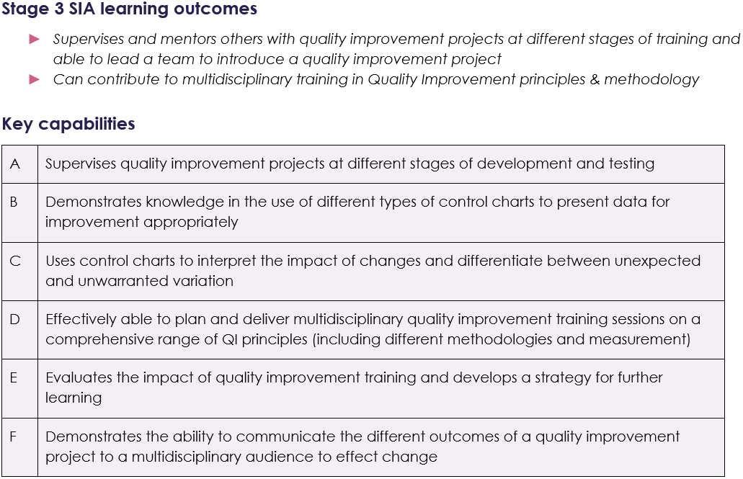

Examples of evidence

Experience and logbook:
- supervises and mentors others with QI projects
- leads a QI project team with a focus on patient safety
- experience in delivery of QI training sessions on a range of topics to different audiences
- if clinical work is done during this time then cases should be documented in the log book.

Supervised Learning Events (SLEs):
- should be completed as part of any clinical work undertaken and linked to relevant Key Capabilities in Stage 3
- A-QIPAT can be used to illustrate own project progression; may also be used to provide feedback on QI projects undertaken by others at different stages of development.

Personal Activities and Personal Reflections may demonstrate:
- experience in application of QI as it relates to patient safety in healthcare
- experience with the collection, organisation and analysis of data for improvement
- experience in mapping and design of safety critical processes against clinical goals
- selection and development of appropriate charts to present data
- presentation of project findings in the form of posters, abstracts and presentations
- the skills necessary to communicate the findings to a wider audience
- engagement with the improvement community through attendance of relevant scientific meetings and conferences

- experience of supervising others undertaking QI projects and able to provide appropriate feedback and guidance
- development of QI educational resources to support learning.

Other evidence:
- satisfactory MSF

Supervision level
- not applicable

Cross links with other domains and capabilities
- Stage 3 non-clinical domains
- Stage 3 clinical key capabilities where appropriate.

Transfer Medicine
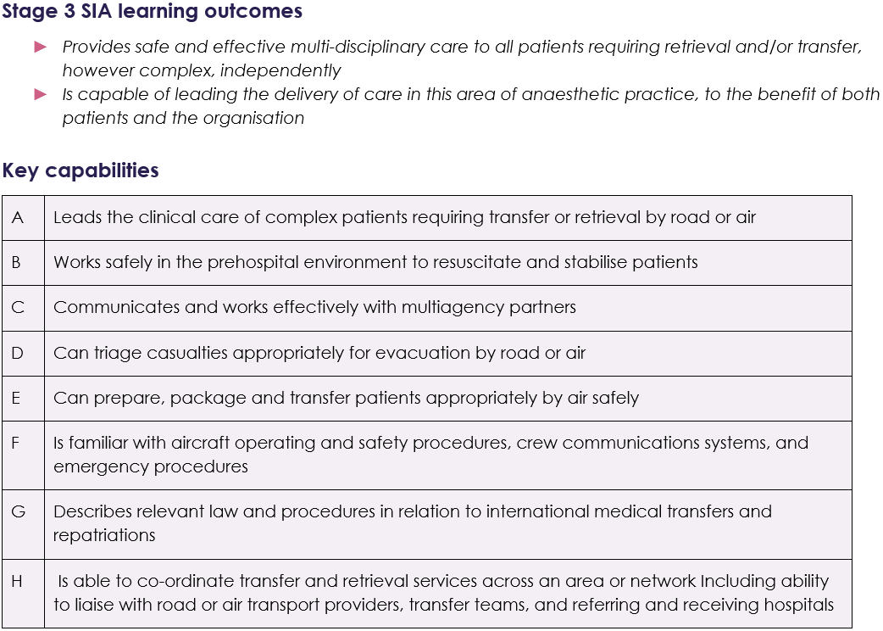

Examples of evidence

Experience and logbook:
- logbook demonstrating experience managing transfer of patients of all ages across a range of transport modalities.

Supervised Learning Events (SLEs) can be used to demonstrate:
- strategies for optimising a patient’s physiology prior to transfer
- ability to coordinate and plan patient transfer demonstrating concurrent activity in managing clinical and non-clinical aspects of the transfer
- consideration for ethical challenges posed by inter-facility transfer
- understanding of the regulations related to land Ambulance, HEMS and Air Ambulance deployment
- ability to differentiate the risks and benefits of road, helicopter and fixed wing transport modalities
- knowledge of the physiological effects of transfer and how these can be effectively minimised
- ability to undertake safe transfer of all age groups of ventilated patients
- knowledge of the potential patient and operational complications with transfer, and how to prepare/mitigate these
- understanding of minimum standards of monitoring during transfer
- clear understanding of the law and principles related to safety; actions taken to ensure safety of both patient and crew
- acknowledgment of futility and avoidance of inappropriate inter-facility transfer.

Personal Activities and Personal Reflections may include:
- attendance at local or national courses related to transfer
- leadership of QI projects related to transfer
- involvement in teaching opportunities relating to transfer
- attendance at pre-hospital/transfer conferences, study days or lectures.

Other evidence:
- satisfactory MSF
- suggested (optional) further qualifications:
  - Diploma in Immediate Retrieval and Transfer from the Royal College of Surgeons of Edinburgh
  - Diploma in Immediate Medical Care from the Royal College of Surgeons of Edinburgh
  - Fellowship in Immediate Medical Care from the Royal College of Surgeons of Edinburgh.

Supervision level
- 4 - should be able to manage independently with no supervisor involvement (although should inform consultant supervisor as appropriate to local protocols).

Cross links with other domains and capabilities
- all non-clinical domains of learning
- General Anaesthesia
- Resuscitation and Transfer
- Pain

Trauma and Stabilisation
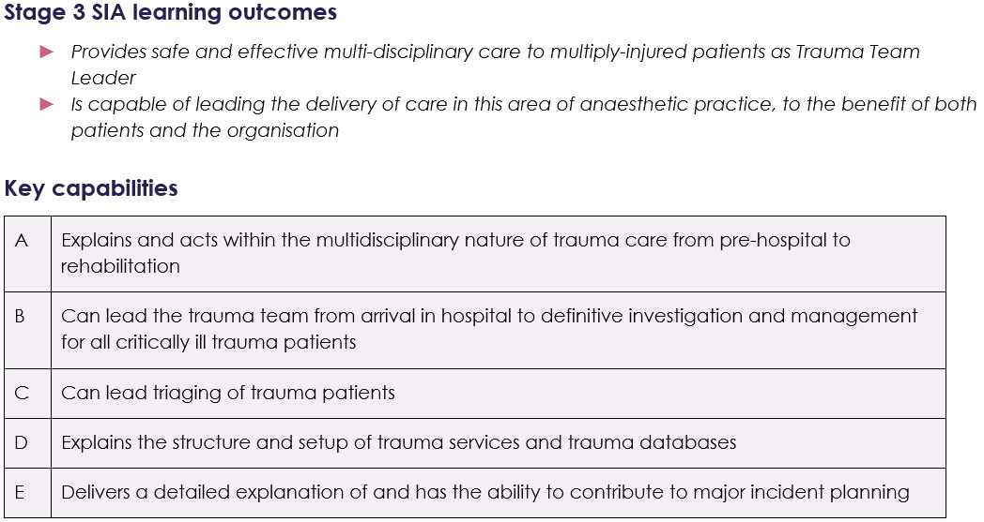

Examples of evidence

Experience and logbook:
- logbook demonstrating experience managing a wide range of trauma patients in both the pre-hospital and in-hospital settings
- logbook evidence for major interventions related to trauma (some of which can be achieved through simulation).

Supervised Learning Events (SLEs) can be used to demonstrate:
- understanding of trauma triage tools and appropriate triage of patients in the pre-hospital environment
- leadership qualities when managing multi-casualty scenarios
- clinical management of the trapped patient and interagency team working to support extrication
- ability to provide safe sedation and pre-hospital emergency anaesthesia to major trauma patients
- ability to recognise and treat the hypovolemic patient including initiation of massive transfusion protocols
- systematic approach to the management of polytrauma patients ensuring effective prioritisation, communication and shared decision making occurs
- safe and effective pharmacological and non-pharmacological management of pain in trauma patients of all age groups
- understanding of the key principles relating to emergency preparedness and initial decontamination and management relating to chemical, biological and radiological (CBR) emergencies. This may be achieved through the use of table top or major incident exercises.
- ability to provide safe clinical assessment, stabilisation and resuscitation of paediatric, obstetric and elderly major trauma patients.

Personal Activities and Personal Reflections may include:
- national and international courses or conferences related to trauma
- leadership of QI projects related to trauma
- attendance at pre-hospital governance days / major trauma meetings
- attendance at pre-hospital conferences, study days or lectures
- presentations at relevant meetings eg abstract or free paper
- involvement in teaching opportunities relating to trauma
- attendance at local Emergency Preparedness / Major Incident exercises
- development of guidelines and policies
- leadership training.

Other evidence:
- satisfactory MSF
- suggested (optional) further qualifications:
  - Diploma in Immediate Medical Care from the Royal College of Surgeons of Edinburgh
  - Fellowship in Immediate Medical Care from the Royal College of Surgeons of Edinburgh.

Supervision level
- 4 - should be able to manage independently with no supervisor involvement (although should inform consultant supervisor as appropriate to local protocols).

Cross links with other domains and capabilities
- all non-clinical domains of learning
- General Anaesthesia
- Resuscitation and Transfer
- Procedural Sedation
- Pain
- Intensive Care

