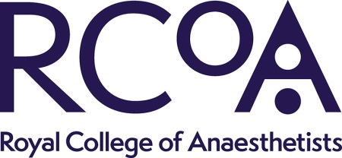
Guidelines for the Provision of Anaesthetic Services Anaesthetist in training representative- Job Description (3 roles)

Role | Anaesthetist in Training representative on the chapter development groups for the following chapters (3 roles available):  - Guidelines for the Provision of Anaesthetic Services: the Good department (1 role)  - Guidelines for the Provision of Anaesthetic Services for the Perioperative Care of Elective and Urgent Care Patients (1 role)  - Guidelines for the Provision of Emergency Anaesthesia (1 role)
Organisation | The Royal College of Anaesthetists (RCoA)

Role description

Summary | Members of the CDG will work in collaboration with the GPAS authors, GPAS Editor, RCoA guidelines project team and the other members of the CDG.  Applicants will have experience of working with multi-professional committees or working groups. Strong interpersonal skills and excellent verbal and written skills are required, along with an ability to communicate complex issues to differing audiences.  Applicants will ideally have an understanding of guideline development processes, systematic reviews, working in committees and critical appraisal methods. Once appointed, the CDG members will work with the GPAS authors responsible for reviewing and presenting the guidelines to the CDG.
Responsibilities | - Review the recommendations within the GPAS chapter and provide feedback  - Work collaboratively with the GPAS authors and RCoA guidelines project team as required at and in between meetings  - Participate in group discussion and decision making during the CDG meeting.  CDG members will be supported by the RCoA guidelines project team who will be responsible for the overall project management of the guidelines including organising CDG meetings (where appropriate), circulating chapter drafts, collating responses from the CDG and keeping version control of the document.
Conditions (e.g. time commitments, length of appointment) | It is anticipated that you will be required to attend one CDG meeting via Microsoft Teams. Subsequent meetings will take place as necessary, and CDG members are expected to make reasonable efforts to attend these meetings.  The majority of correspondence will be via email. CDG members will be asked to review the chapter draft and provide feedback where appropriate.

Person specification
 | Essential Criteria
Experience | - Experience in anaesthesia or anaesthesia-related healthcare as a practising health professional or experience of health care commissioning (dependent on the role in the group)  - Credible level of experience of expert committee work or standards setting work in a relevant setting.
Skills | Excellent verbal and written communication skills
Knowledge | A detailed knowledge of anaesthesia and/or anaesthesia-related health expertise (dependent on role in the group)
Other | Clear reasoning for any suggestions made during the chapter development process

