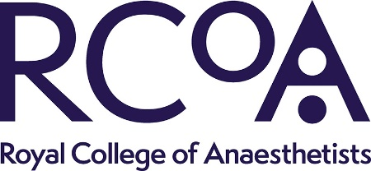

Job Description for Question Bank Lead,
ST4 Anaesthetics Recruitment Delivery Group

Key tasks and responsibilities
The role holder will lead a small working group from within the Committee to deliver the following;
- Manage the existing secure question bank database (held on RCoA Teams files) for National Recruitment.
- Standardise and revise current questions and develop new questions.
- To conduct question-writing webinars/in-person events as required.
- Set the questions for the two annual interview rounds (February and August intakes) and send materials to recruitment coordinator.
- Respond to regional or ANRO queries about the interview materials prior to the days of interview as required
- In collaboration with QA lead, analyse interviewer feedback on questions.
- Adapt and modify questions as needed in response to interviewer feedback.
- Report to the Recruitment Committee on question development.
- Present updates on Interview question process at the Stakeholder Events as required.
- Work with the Recruitment Committee Chair to develop the interview scoring matrix.
- To attend the RC meetings and Stakeholder Events. (please see below for frequency of meetings).
Eligibility
- Practising substantive Consultant/SAS doctor in Anaesthetics in the NHS
- Member/Associate Member of the Royal College of Anaesthetists in good standing
- Active experience in National Recruitment and representation of local region at National/Regional interviews
- Support of employing LEP / Trust to undertake these duties.
The RC meet three times a year and two of those meetings include the recruitment
stakeholder event which is held in the morning on the same day as the committee
meeting. The meetings are one in person at the college and two virtual meetings a year.

Please note as a member of the RC your travel and any accommodation expenses for these
meetings will be covered by the RCoA.

How to Apply

Please complete the Anaesthetics Recruitment Executive Committee application form and send it along with a brief CV (no more than 2 pages) to recruitment@rcoa.ac.uk before the deadline.

