Certificate of Achievement

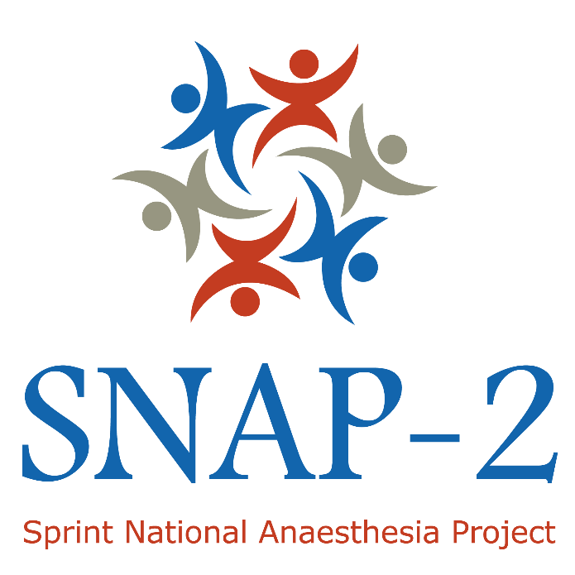

This is to certify that ________________________________ contributed significantly to local study coordination and data collection for the Second Sprint National Anaesthesia Project: Epidemiology of Critical Care provision after Surgery, which recruited patients from 21 March to 27 March 2017, with a one-week follow-up that ended on 3 April 2017.
We are very grateful for the contribution.

Sincerely,

Insert name and position of local Principal Investigator

Learning Objectives and Mapping to the CCT in Anaesthetics
By participating in SNAP-2: EpiCCS, local collaborators have the opportunity to develop the following competencies from Annex G of the CCT in Anaesthetics Curriculum 2010 (Teaching and training, academic and research (including audit), quality improvement, and management for anaesthesia, critical care and pain medicine).
AR_IK_05 Describes and explains the methodology and processes of clinical research, including but not exclusively: -Ethical and approval considerations raised by research; -The importance of study design in clinical research; -The importance of statistical analyses ☐
AR_IK_08 Demonstrates a knowledge of research principles ☐
AR_HK_01 Understands their role in supporting quality through participating in and promoting audit of clinical outcomes ☐
AR_HK_03 Know the principles of research governance ☐
AR_HK_05 Knows about the National Institute for Academic Anaesthesia ☐
AR_HS_12 Encourages discussion amongst colleagues on evidence-based practice ☐
AR_HS_15 Identifies the ethical issues relating to the organisation of clinical research ☐
AR_AK_08 Understands material specifically related to their ‘project’ ☐
AR_AS_05 Shows willingness to encourage and take part in research ☐
AR_AS_07 Follows guidelines on ethical conduct in research and consent for research ☐

