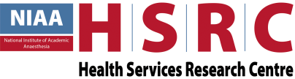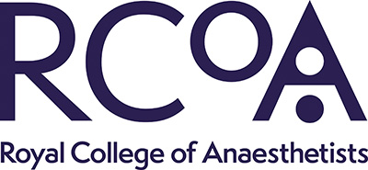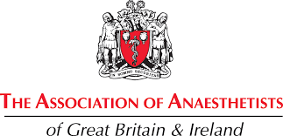

OUR HOSPITAL IS PARTICIPATING IN THE
2ND SPRINT NATIONAL ANAESTHESIA PROJECT (SNAP-2)

SNAP-2 is a national clinical study which is being carried out in the majority of hospitals in the UK.
SNAP-2 will be collecting information about the medical care of inpatients undergoing surgery.

IF YOU WOULD LIKE FURTHER INFORMATION ABOUT WHAT THIS MEANS PLEASE ASK THE LOCAL PRINCIPAL INVESTIGATOR
[INSERT NAME & DEPARTMENT]
-
GO TO THE SNAP-2 STUDY WEBSITE –
http://www.niaa-hsrc.org.uk/SNAP-2
-
OR CONTACT US VIA EMAIL – snap2@rcoa.ac.uk

